**Sql Cheetsheet**

DATA: Collection of facts related to some object.

DATABASE: An organized collection of data.

DBMS/RDBMS: (Relational Database Management System) Collection of tools(software) that allows the users to manipulate, organize and visualize the contents of a database.

SQL: (SEQUEL or Structured Query Language) system for querying — requesting, filtering, and outputting data from RDBMS.



**QUERYING DATA FROM A TABLE**

1 . Data Definition Language(DDL): SQL commands used to create, modify, and delete database structures but not data.

CREATE: Used to create a new table in the database.

Create database college_data --- create database

Ex: CREATE TABLE STUDENT(Name VARCHAR2(20), Email VARCHAR2(100), DOB DATE);

ALTER: Used to alter contents of a table by adding some new column or attribute, or changing some existing attribute.

Ex: ALTER TABLE STUDENT ADD(ADDRESS VARCHAR2(20)); -- Add new column address

ALTER TABLE STUDENT MODIFY (ADDRESS VARCHAR2(20)); --- change datatype of column

ALTER TABLE student DROP COLUMN email; --- Drop column email from the student table

ALTER TABLE student ADD constraint; --- Add a constraint

**ALTER TABLE student DROP constraint; ---**Drop constraint

ALTER TABLE STUDENT RENAME TO STUDENTS; --- Rename a table from STUDENT to STUDENTS

ALTER TABLE STUDENT RENAME TO STUDENTS email TO EMAIL; Rename column email to EMAIL.

DROP: Used to delete the structure and record stored in the table.

Ex: DROP TABLE STUDENT;

TRUNCATE: Used to delete all the rows from the table, and free up the space in the table.

TRUNCATE TABLE STUDENT;

2. Data Manipulation Language(DML): Statements access and manipulate data in existing tables.

**INSERT:** Used to insert data in the row of a table.

INSERT INTO STUDENT (Name, Subject) VALUES ("Scaler", "DSA")

we insert the values “Scaler” and “DSA” in the columns Name and Subject in the STUDENT table.

**UPDATE:** Used to update value of a table’s column.

UPDATE STUDENT SET User_Name = 'suvidha' WHERE Student_Id = '2'

update the name of the student, whose Student_ID is 2, to the User_Name = “suvidha”.

DELETE: Used to delete one or more rows in a table.

DELETE FROM STUDENT WHERE Name = "suvidha"

3. Data Control Language(DCL): Commands are used to grant and take back access/authority (revoke) from any database user.

Grant: Used to grant a user access privileges to a database.

Ex: GRANT SELECT, UPDATE ON TABLE_1 TO USER_1, USER_2;

we grant the rights to SELECT and UPDATE data from the table TABLE_1 to users - USER_1 and USER_2.

Revoke: Used to revoke the permissions from an user.

Ex: REVOKE SELECT, UPDATE ON TABLE_1 FROM USER_1, USER_2;

we revoke the rights to SELECT and UPDATE data from the table TABLE_1 from the users- USER_1 and USER_2.

4. Transaction Control Language: Used only with DML commands in conjunction and belong to the category of auto-committed commands.

COMMIT: Saves all the transactions made on a database.

DELETE FROM STUDENTS WHERE AGE = 16; COMMIT;

we delete the row where AGE of the students is 16, and then save this change to the database using COMMIT.

ROLLBACK: It is used to undo transactions which are not yet been saved.

DELETE FROM STUDENTS WHERE AGE = 16; ROLLBACK;

ROLLBACK in the above example, we can undo the deletion we performed in the previous line of code, because the changes are not committed yet.

SAVEPOINT: Used to roll transaction back to a certain point without having to roll back the entirity of the transaction.

Ex: SAVEPOINT SAVED;

DELETE FROM STUDENTS WHERE AGE = 16; ROLLBACK TO SAVED;

we have created a savepoint just before performing the delete operation in the table, and then we can return to that savepoint using the ROLLBACK TO command.

5. Data Query Language: It is used to fetch some data from a database.

SELECT: Retrieves data from one or more tables in the database.

Example: With WHERE clause,

SELECT Name FROM Student WHERE age >= 18;

Without WHERE clause : SELECT Name FROM Student

Clauses in SQL

Clauses are in-built functions that helps to fetch or access the required records from the database table

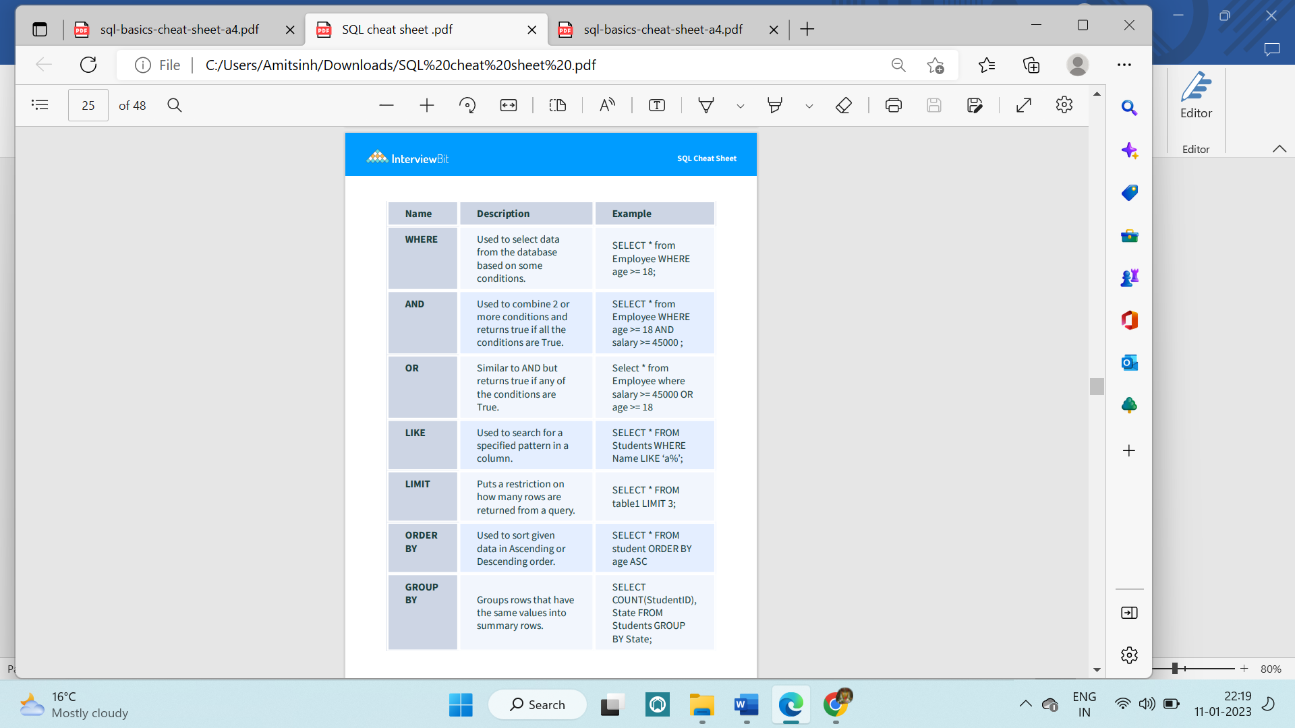

**ALIASES**

**Aliases** are the temporary names given to table or column for the purpose of a particular **SQL** query • If the alias name contains spaces then it required to be in double quotes

COLUMNS SELECT name AS city_name FROM city;

TABLES SELECT co.name, ci.name FROM city AS ci JOIN country AS co ON ci.country_id = co.id

**AGGREGATION AND GROUPING**

**Aggregation** allows us to combine results by **grouping** records based on value.

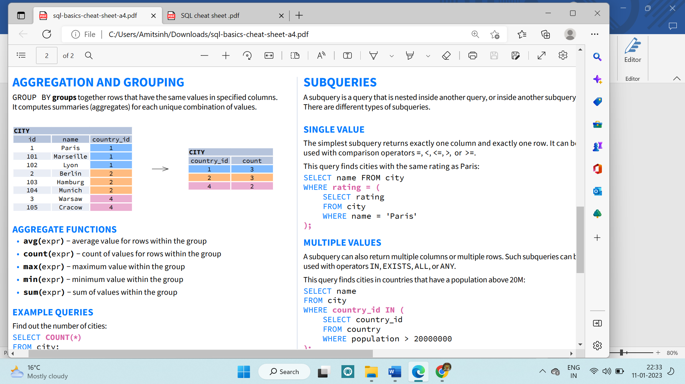

avg(expr) − average value for rows within the group

count(expr) − count of values for rows within the group

max(expr) − maximum value within the group •

min(expr) − minimum value within the group •

sum(expr) − sum of values within the group

EXAMPLE QUERIES

Find out the number of cities:

SELECT COUNT(*) FROM city;

Find out the number of cities with non-null ratings:

SELECT COUNT(rating) FROM city;

Find out the number of distinctive country values:

SELECT COUNT(DISTINCT country_id) FROM city;

Find out the smallest and the greatest country populations:

SELECT MIN(population), MAX(population) FROM country;

Find out the total population of cities in respective countries:

SELECT country_id, SUM(population) FROM city GROUP BY country_id;

Find out the average rating for cities in respective countries if the average is above 3.0:

SELECT country_id, AVG(rating) FROM city GROUP BY country_id HAVING AVG(rating) > 3.0

Order of Execution

FROM 🡪 WHERE🡪 GROUP BY 🡪HAVING🡪 SELECT 🡪ORDER BY 🡪LIMIT

Constraints

Applying certain conditions or restrictions on the database.

A CONSTRAINT can be one of the following:

* a column-level constraint

Column-level constraints refer to a single column in the table and do not specify a column name (except check constraints). They refer to the column that they follow.

* a table-level constraint

Table-level constraints refer to one or more columns in the table. Table-level constraints specify the names of the columns to which they apply. Table-level CHECK constraints can refer to 0 or more columns in the table.

NOT Null constraint can only apply on column level. Not for table level

Syntax of table level constraint : constraint constraint_name constraint type (column name)

Types of Keys

1. Primary Key: They uniquely identify a row in a table. Only a single primary key for a table

The primary key column cannot have any NULL values.

The primary key must be unique for each row.

CREATE TABLE Student ( ID int NOT NULL, LastName varchar(255) NOT NULL, FirstName varchar(255), Class int, PRIMARY KEY (ID) );

1. Foreign Key: Foreign keys are keys that reference the primary keys of some other table. They establish a relationship between 2 tables and link them up.

CREATE TABLE Orders ( OrderID int NOT NULL, OrderNumber int NOT NULL, PersonID int, PRIMARY KEY (OrderID), FOREIGN KEY (PersonID) REFERENCES Persons(PersonID);

1. Unique key Specifies that values in the column must be unique.
2. Not null: CREATE TABLE Orders ( OrderID int NOT NULL, OrderNumber int NOT NULL, PersonID int,)
3. Check Constraint:

A check constraint can be used to specify a wide range of rules for the contents of a table.

A search condition (which is a boolean expression) is specified for a check constraint. This search condition must be satisfied for all rows in the table.

Example:

Use a column-level constraint for an arithmetic check

-- Use a table-level constraint

-- to make sure that a employee's taxes does not

-- exceed the bonus

**Joins in SQL**

JOIN (or explicitly INNER JOIN) returns rows that have matching values in both tables.

Example: Consider the following tables,

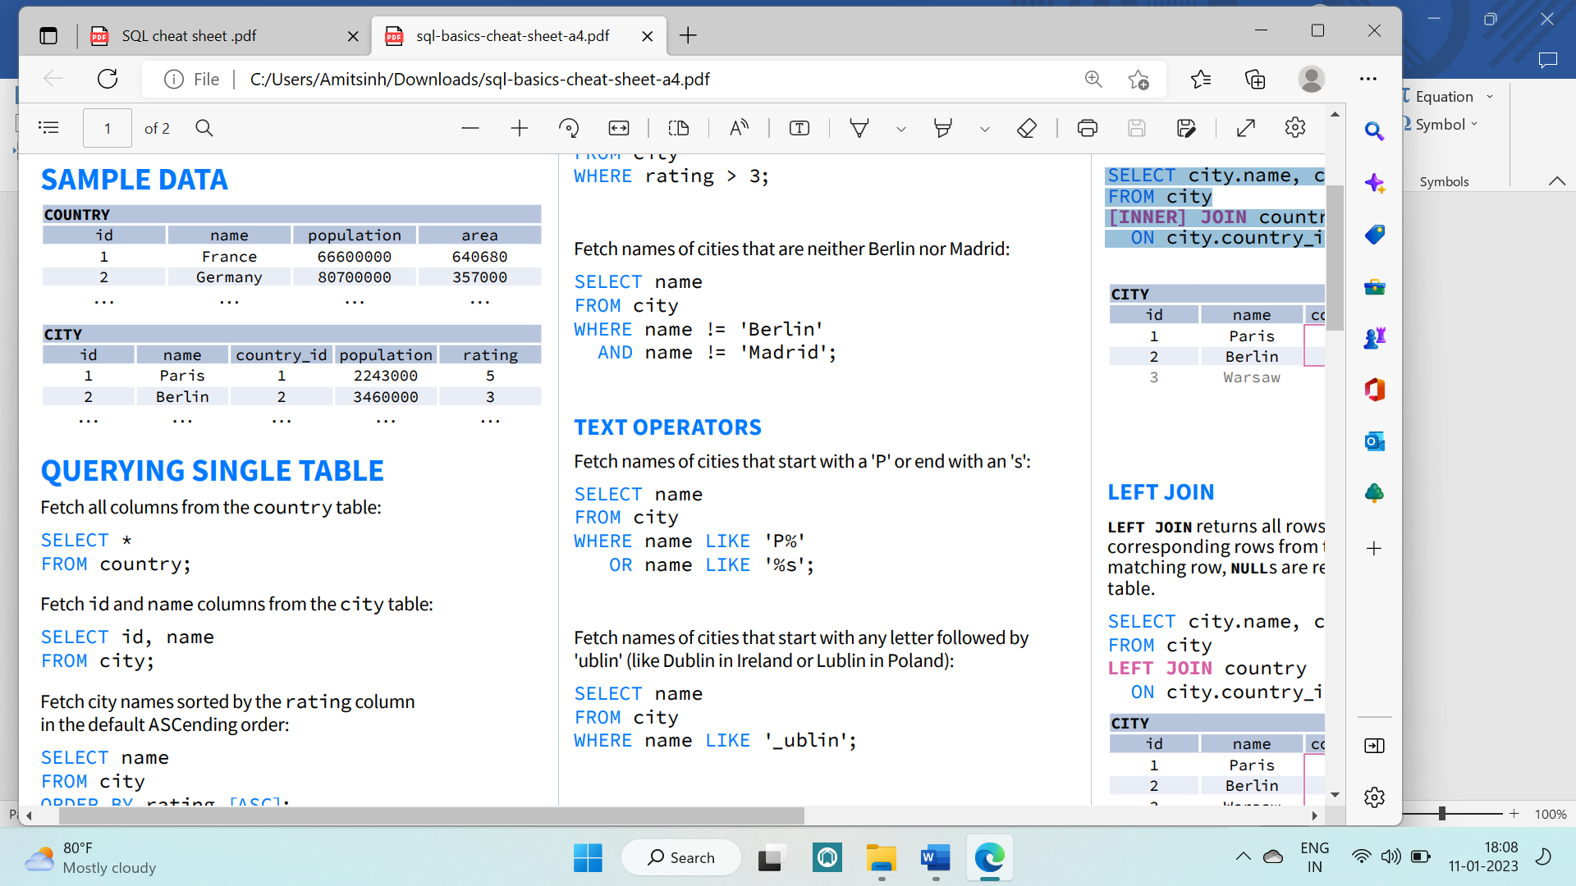

INNER JOIN

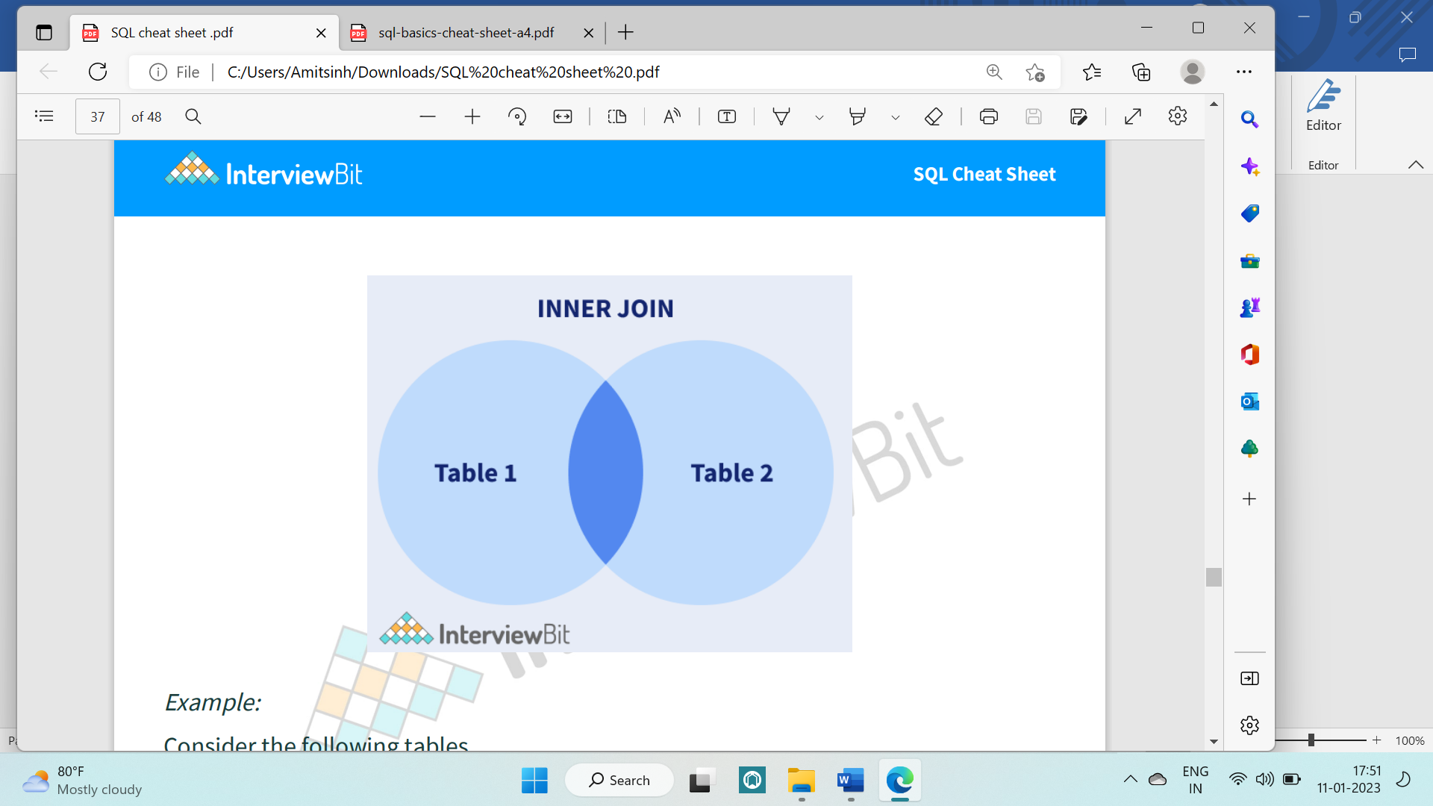

SELECT city.name, country.name FROM city [INNER] JOIN country ON city.country_id = country.id;

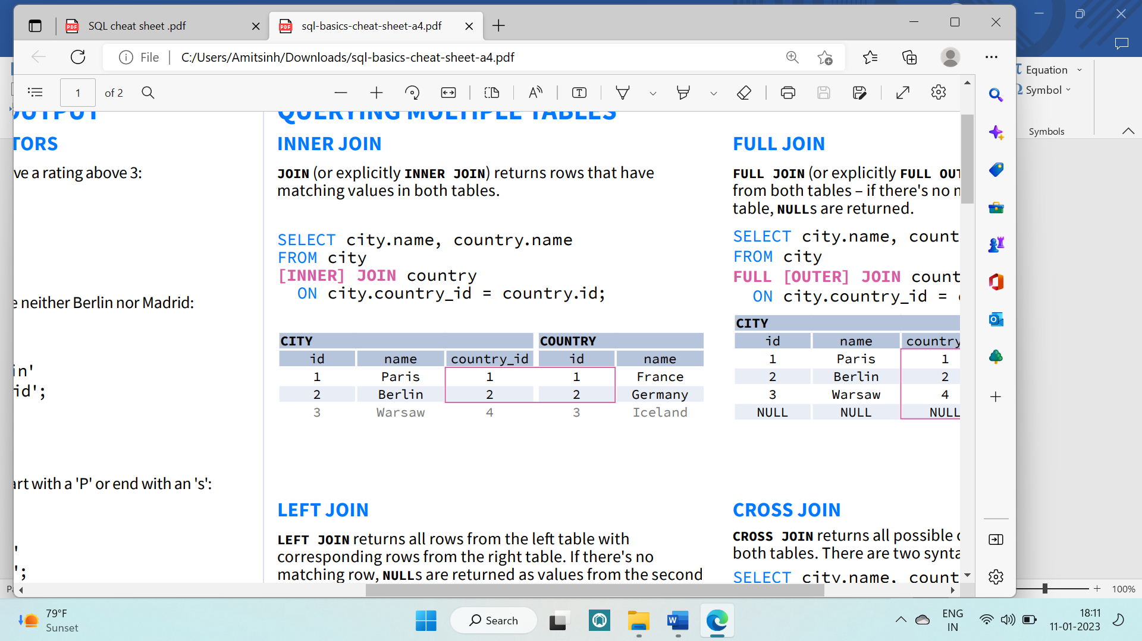

NATURAL JOIN: It is a special type of inner join based on the fact that the column names and datatypes are the same on both tables.

SELECT city.name, country.name FROM city NATURAL JOIN country;

NATURAL JOIN used these columns to match rows: city.id, city.name, country.id, country.name NATURAL JOIN is very rarely used in practice

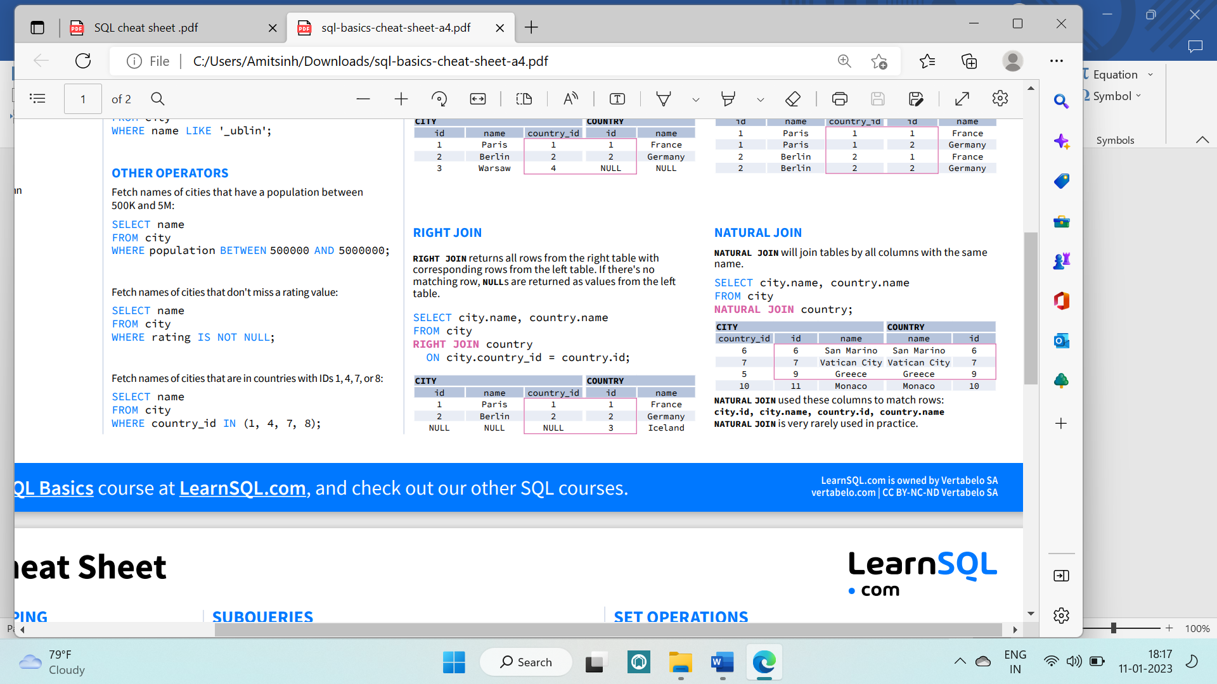

RIGHT JOIN: Returns all of the records from the second table(right), along with any matching records from the first(left).

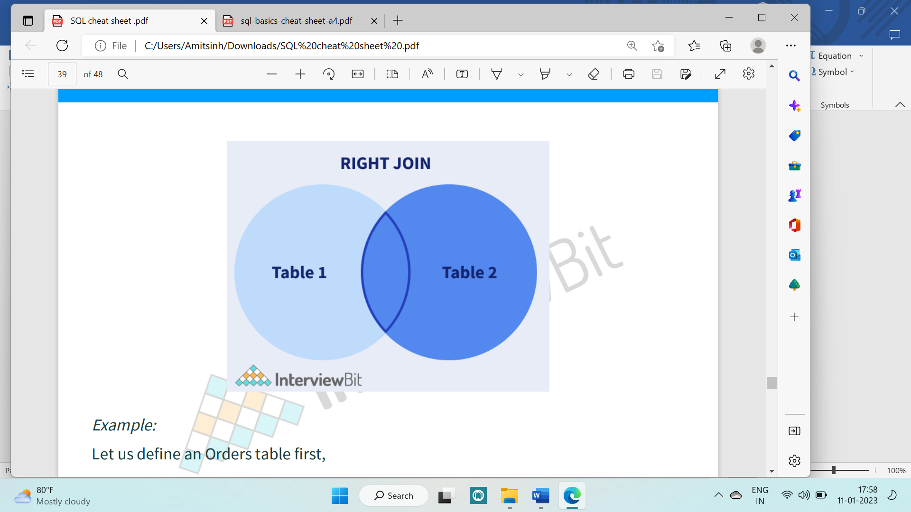

SELECT city.name, country.name FROM city RIGHT JOIN country ON city.country_id = country.id;

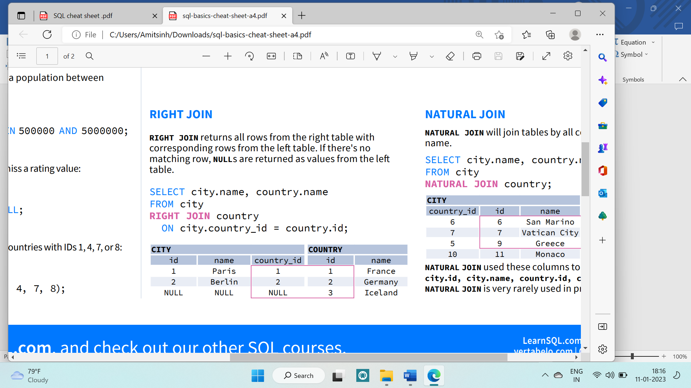

LEFT JOIN: Returns all of the records from the first table, along with any matching records from the second table.If there's no matching row, NULLs are returned as values from the second table.

SELECT city.name, country.name FROM city LEFT JOIN country ON city.country_id = country.id;

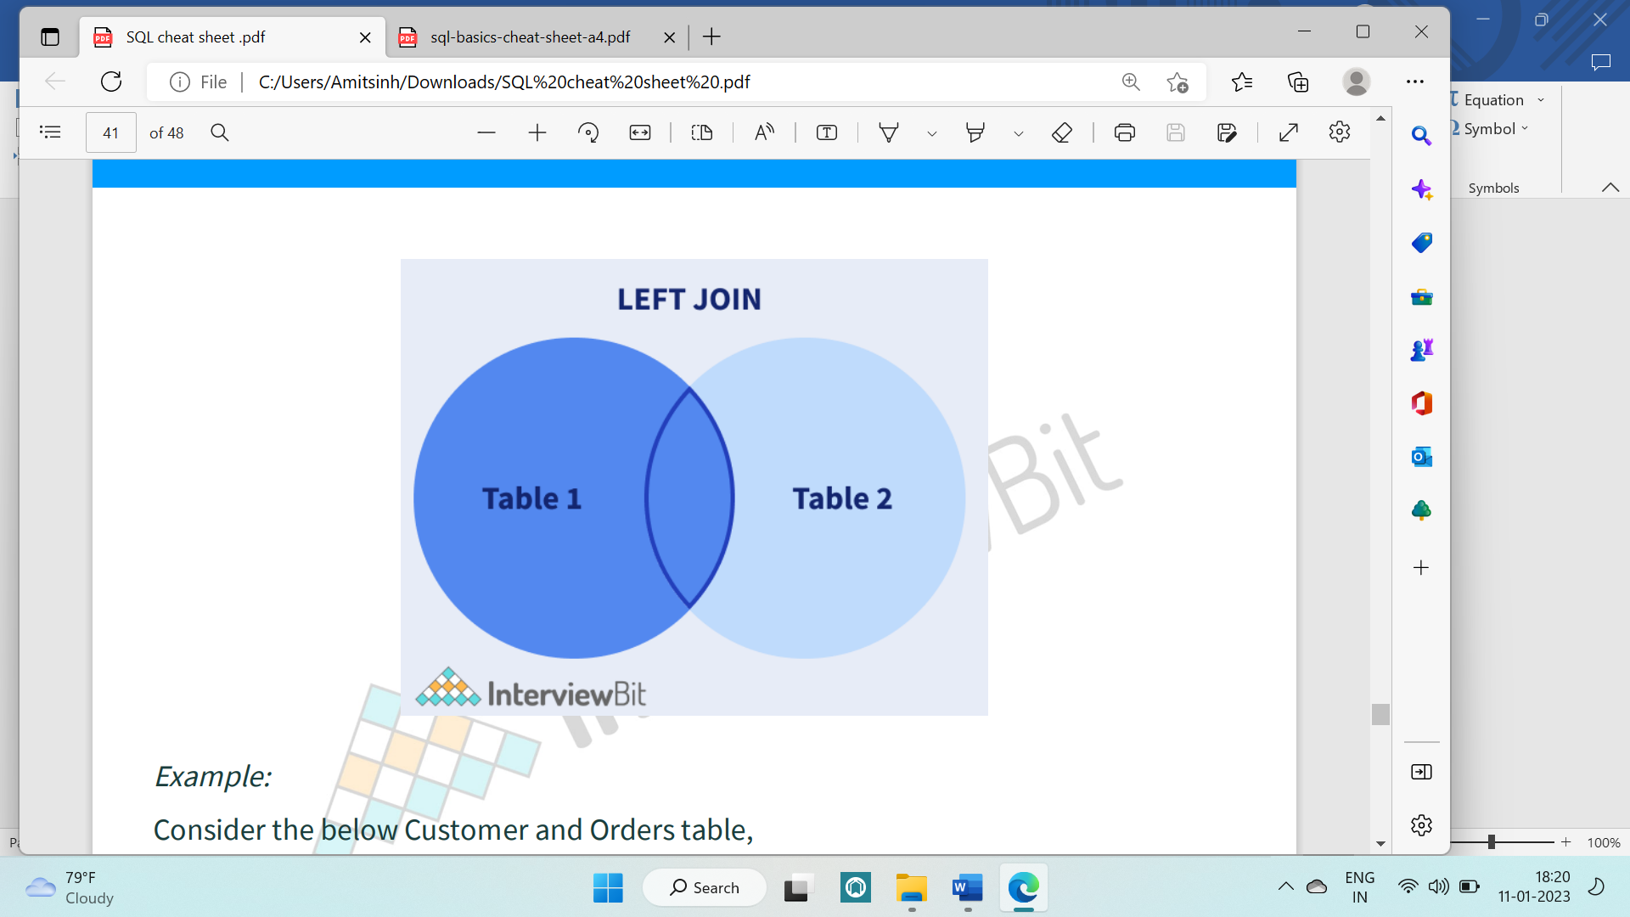

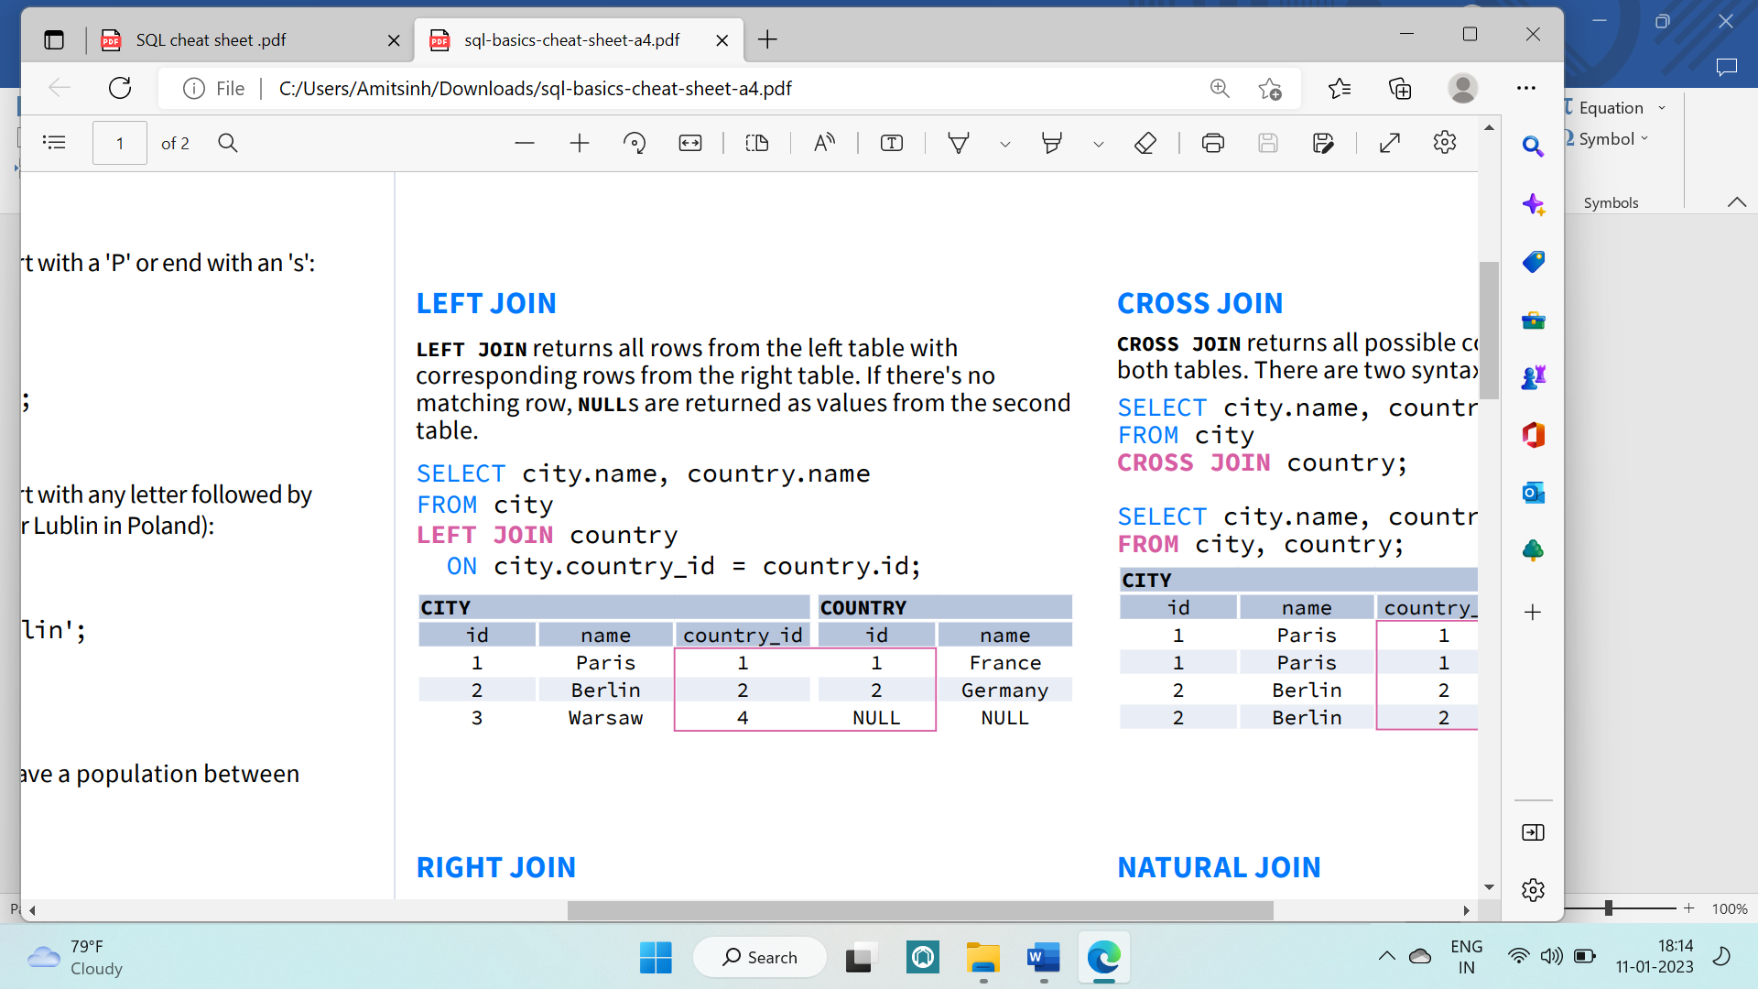

FULL JOIN (or explicitly FULL OUTER JOIN) returns all rows from both tables – if there's no matching row in the second table, NULLs are returned.

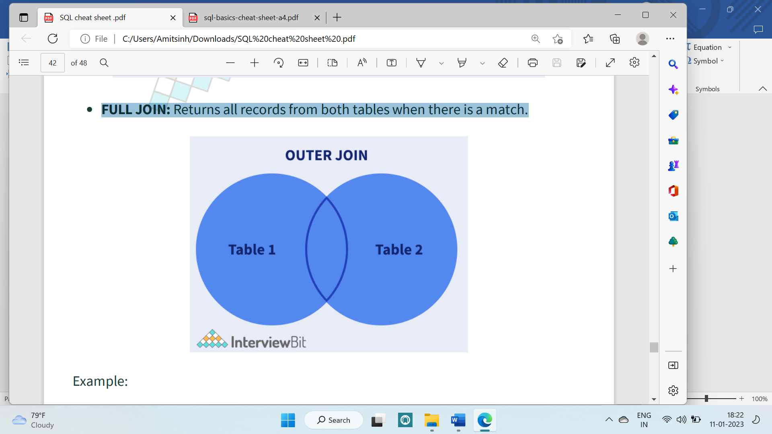

SELECT city.name, country.name FROM city FULL [OUTER] JOIN country ON city.country_id = country.id;

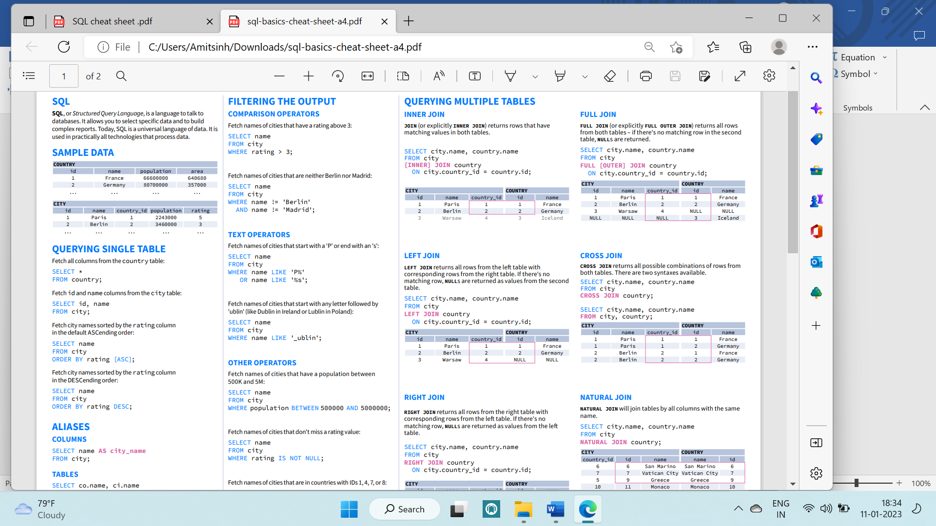

CROSS JOIN

SELECT city.name, country.name FROM city CROSS JOIN country;

SELECT city.name, country.name FROM city, country;

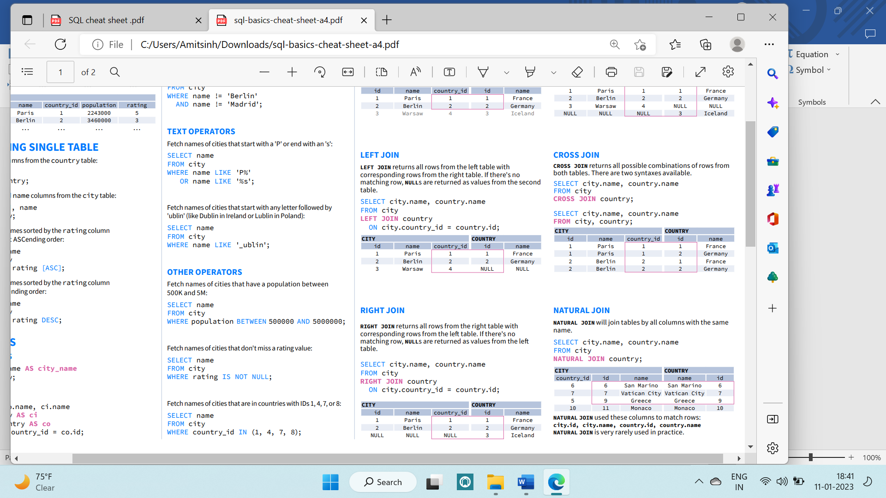

**SUBQUERIES**

A **subquery** is a query within another query.

SINGLE VALUE

The simplest subquery returns exactly one column and exactly one row. It can be used with comparison operators =, <=, >, or >=.

This query finds cities with the same rating as Paris

SELECT name FROM city WHERE rating = ( SELECT rating FROM city WHERE name = 'Paris' );

MULTIPLE VALUES

A subquery can also return multiple columns or multiple rows. Such subqueries can be used with operators IN, EXISTS, ALL, or ANY.

This query finds cities in countries that have a population above 20M:

SELECT name FROM city WHERE country_id IN ( SELECT country_id FROM country WHERE population > 20000000 );

CORRELATED

A correlated subquery refers to the tables introduced in the outer query. A correlated subquery depends on the outer query. It cannot be run independently from the outer query.

This query finds cities with a population greater than the average population in the country.

SELECT * FROM city main_city WHERE population > ( SELECT AVG(population) FROM city average_city WHERE average_city.country_id = main_city.country_id );

This query finds countries that have at least one city:

SELECT name FROM country WHERE EXISTS ( SELECT * FROM city WHERE country_id = country.id );

**SET OPERATIONS**

Combine the results of two or more queries into a single result. The combined queries must return the same number of columns and compatible data types. The names of the corresponding columns can be different

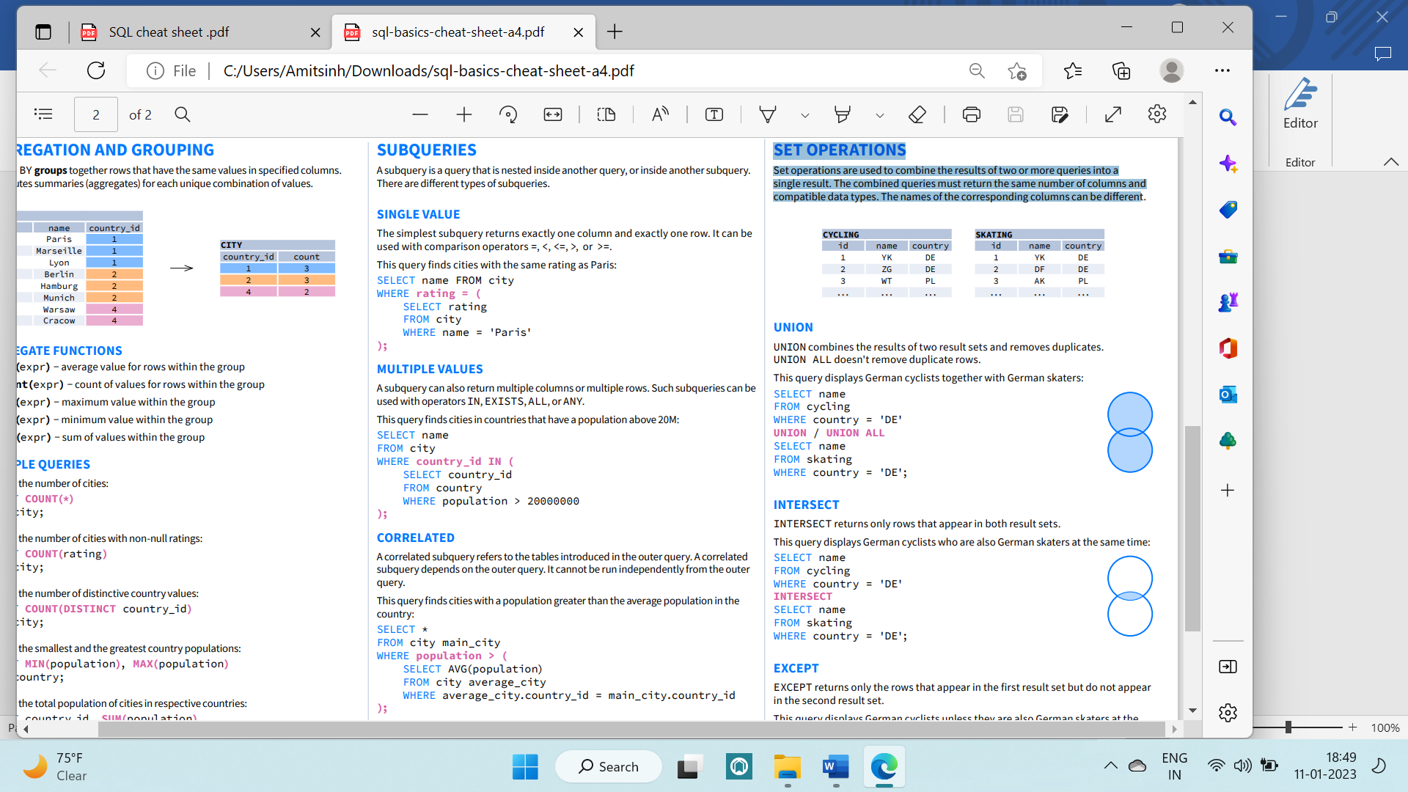

UNION

UNION combines the results of two result sets and removes duplicates. UNION ALL doesn't remove duplicate rows. This query displays German cyclists together with German skaters:

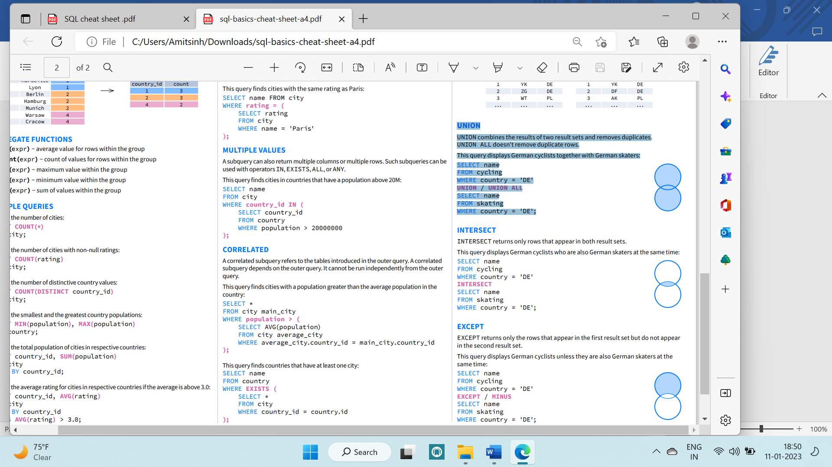

SELECT name FROM cycling WHERE country = 'DE' UNION / UNION ALL SELECT name FROM skating WHERE country = 'DE';

INTERSECT



INTERSECT returns only rows that appear in both result sets.

This query displays German cyclists who are also German skaters at the same time

SELECT name FROM cycling WHERE country = 'DE' INTERSECT SELECT name FROM skating WHERE country = 'DE';

EXCEPT (MINUS)

EXCEPT returns only the rows that appear in the first result set but do not appear in the second result set. This query displays German cyclists unless they are also German

SELECT name FROM cycling WHERE country = 'DE' EXCEPT / MINUS SELECT name FROM skating WHERE country = 'DE' skaters at the



Constraints

A database consists of multiple tables and these tables and their contents are related to each other by some relations/conditions. To identify each row of these tables uniquely, we make use of SQL keys. A SQL key can be a single column or a group of columns used to uniquely identify the rows of a table. SQL keys are a means to ensure that no row will have duplicate values. They are also a means to establish relations between multiple tables in a database.

A CONSTRAINT can be one of the following:

* a column-level constraint

Column-level constraints refer to a single column in the table and do not specify a column name (except check constraints). They refer to the column that they follow.

* a table-level constraint

Table-level constraints refer to one or more columns in the table. Table-level constraints specify the names of the columns to which they apply. Table-level CHECK constraints can refer to 0 or more columns in the table.

NOT Null constraint can only apply on column level. Not for table level

Syntax of table level constraint : constraint constraint_name constraint type (column name)

Types of Keys

1. Primary Key: They uniquely identify a row in a table. Only a single primary key for a table

The primary key column cannot have any NULL values.

The primary key must be unique for each row.

CREATE TABLE Student ( ID int NOT NULL, LastName varchar(255) NOT NULL, FirstName varchar(255), Class int, PRIMARY KEY (ID) );

1. Foreign Key: Foreign keys are keys that reference the primary keys of some other table. They establish a relationship between 2 tables and link them up.

CREATE TABLE Orders ( OrderID int NOT NULL, OrderNumber int NOT NULL, PersonID int, PRIMARY KEY (OrderID), FOREIGN KEY (PersonID) REFERENCES Persons(PersonID);

1. Unique key Specifies that values in the column must be unique.
2. Not null: CREATE TABLE Orders ( OrderID int NOT NULL, OrderNumber int NOT NULL, PersonID int,)
3. Check Constraint:

A check constraint can be used to specify a wide range of rules for the contents of a table.

A search condition (which is a boolean expression) is specified for a check constraint. This search condition must be satisfied for all rows in the table.

Example:

Use a column-level constraint for an arithmetic check

-- Use a table-level constraint

-- to make sure that a employee's taxes does not

-- exceed the bonus

CREATE TABLE SAMP.EMP

(

EMPNO CHAR(6) NOT NULL CONSTRAINT EMP_PK PRIMARY KEY,

FIRSTNME CHAR(12) NOT NULL,

MIDINIT vARCHAR(12) NOT NULL,

LASTNAME VARCHAR(15) NOT NULL,

SALARY DECIMAL(9,2) CONSTRAINT SAL_CK CHECK (SALARY >= 10000),

BONUS DECIMAL(9,2),

TAX DECIMAL(9,2),

CONSTRAINT BONUS_CK CHECK (BONUS > TAX)

);